**Why has Participatory Budgeting declined in Brazil?**

Carla de Paiva Bezerra

Phone: +5511975855594. E-mail: [carla.bezerra@gmail.com](mailto:carla.bezerra@gmail.com). ORCID: <https://orcid.org/0000-0001-5238-354X>. Mailing Adress: CEBRAP, Rua Morgado de Mateus, 185, Vila Mariana, São Paulo – SP, Brazil, ZIP code 04015-051.

Murilo de Oliveira Junqueira

Phone: +5511976682097. E-mail: [m.junqueira@yahoo.com.br](mailto:m.junqueira@yahoo.com.br). ORCID: <https://orcid.org/0000-0003-3033-379X>. Mailing Adress: UFPA-PPGCP, R. Augusto Corrêa, 01 - Guamá, Belém - PA, Brazil, ZIP code: 66075-110.

**Conflicts of Interest:** Carla de Paiva Bezerra and Murilo de Oliveira Junqueira declare none.

**Abstract**[1]

Participatory Budgeting (PB) is a policy innovation that originated in Brazil and is recognized worldwide by researchers and international organizations as an effective policy tool for directly involving the population in decisions about the local budget. Its diffusion in Brazil was strongly stimulated by the Workers' Party (Partido dos Trabalhadores - PT), as a showcase of the "Petista Way of Governing.” However, when the Party took Federal Office, it abandoned PB as its main participatory policy priority. The motivation for such drastic change in policy preference remains unexplained, by both scholars and the Party itself. To understand the reasons for it, we present an original hypothesis based on party adaptation to increasing fiscal and budgetary rigidity. Using panel-data analysis, our research shows that the financial variables have a strong predictive power to explain PB adoption, continuity and abandon between 1996 and 2016.

**Keywords**: Participatory Budgeting; Workers Party; Fiscal Policy; Political Institutions.

**Introduction**

Participatory Budgeting (PB) is a democratic innovation policy tool that enables direct involvement of the population in decisions about the local budget. Its output is the definition of priority investments, usually by neighborhood (Wampler 2008, p. 69). Workers' Party (Partido dos Trabalhadores - PT) activists, politicians and bureaucrats created PB in the city of Porto Alegre, Brazil, in 1990. Later, in 1996, UN Habitat acknowledged it as a “Good Practice for Urban Governance.”[2] Since then, the World Bank and activist networks have promoted its diffusion worldwide, which made PB and its foundational experience the subject of several scholarly studies (Douglass and Friedmann 1998, Abers 2000, Avritzer and Navarro 2003, Baiocchi 2003, Wampler 2007, Santos and Avritzer, 2002). It has been adopted both nationally and by local governments worldwide, but the most successful and well known cases are in Latin America (Brazil, Peru, Argentina, Uruguay, Ecuador, Colombia) and Europe (Portugal, Italy, Germany, Spain and France) (Cabannes 2004, Shah 2007, Oliveira 2018, Goldfrank 2012, Sintomer, Herzberg, Röcke, Allegretti 2012).

Between 1989 and 2012, 256 Brazilian prefectures of various political parties adopted Participatory Budgets for at least one administrative period. However, the PT accounts for most of the cases, both in relative and absolute numbers (see figure 1), and the policy is clearly associated with this party. The peak of PB adoption in Brazil occurred precisely at the moment of the PT's election to the Federal Government in 2002 (for the 2003-2006 term), followed by a continuous decrease until 2012, which, if kept constant, would mean the disappearance of Participatory Budgeting in Brazil by the year 2024 (Spada 2012). Despite decreasing in Brazil, its place of origin, PB keeps expanding worldwide (Oliveira 2018, Cabannes 2004, Shah 2007, Sintomer, Herzberg, Röcke, Allegretti 2012).

PB diffusion follows the PT's electoral growth, at least until the early 2000s. However, when the PT took Federal Office, it abandoned Participatory Budgeting as a high priority policy, stimulating other forms of civil society participation instead. Although Lula’s 2002 presidential proposals included “to implement a national PB,” the proposal simply disappeared from the Party’s documents and debates after the election (Bezerra 2014). Similarly, while in Federal Office, the PT did not create any policy mechanism to promote local governments to keep adopting PB. The motivation for such drastic change in policy preference remains unexplained, by both scholars and the Party itself.

**Figure 1 - Participatory Budget over time in Brazil**

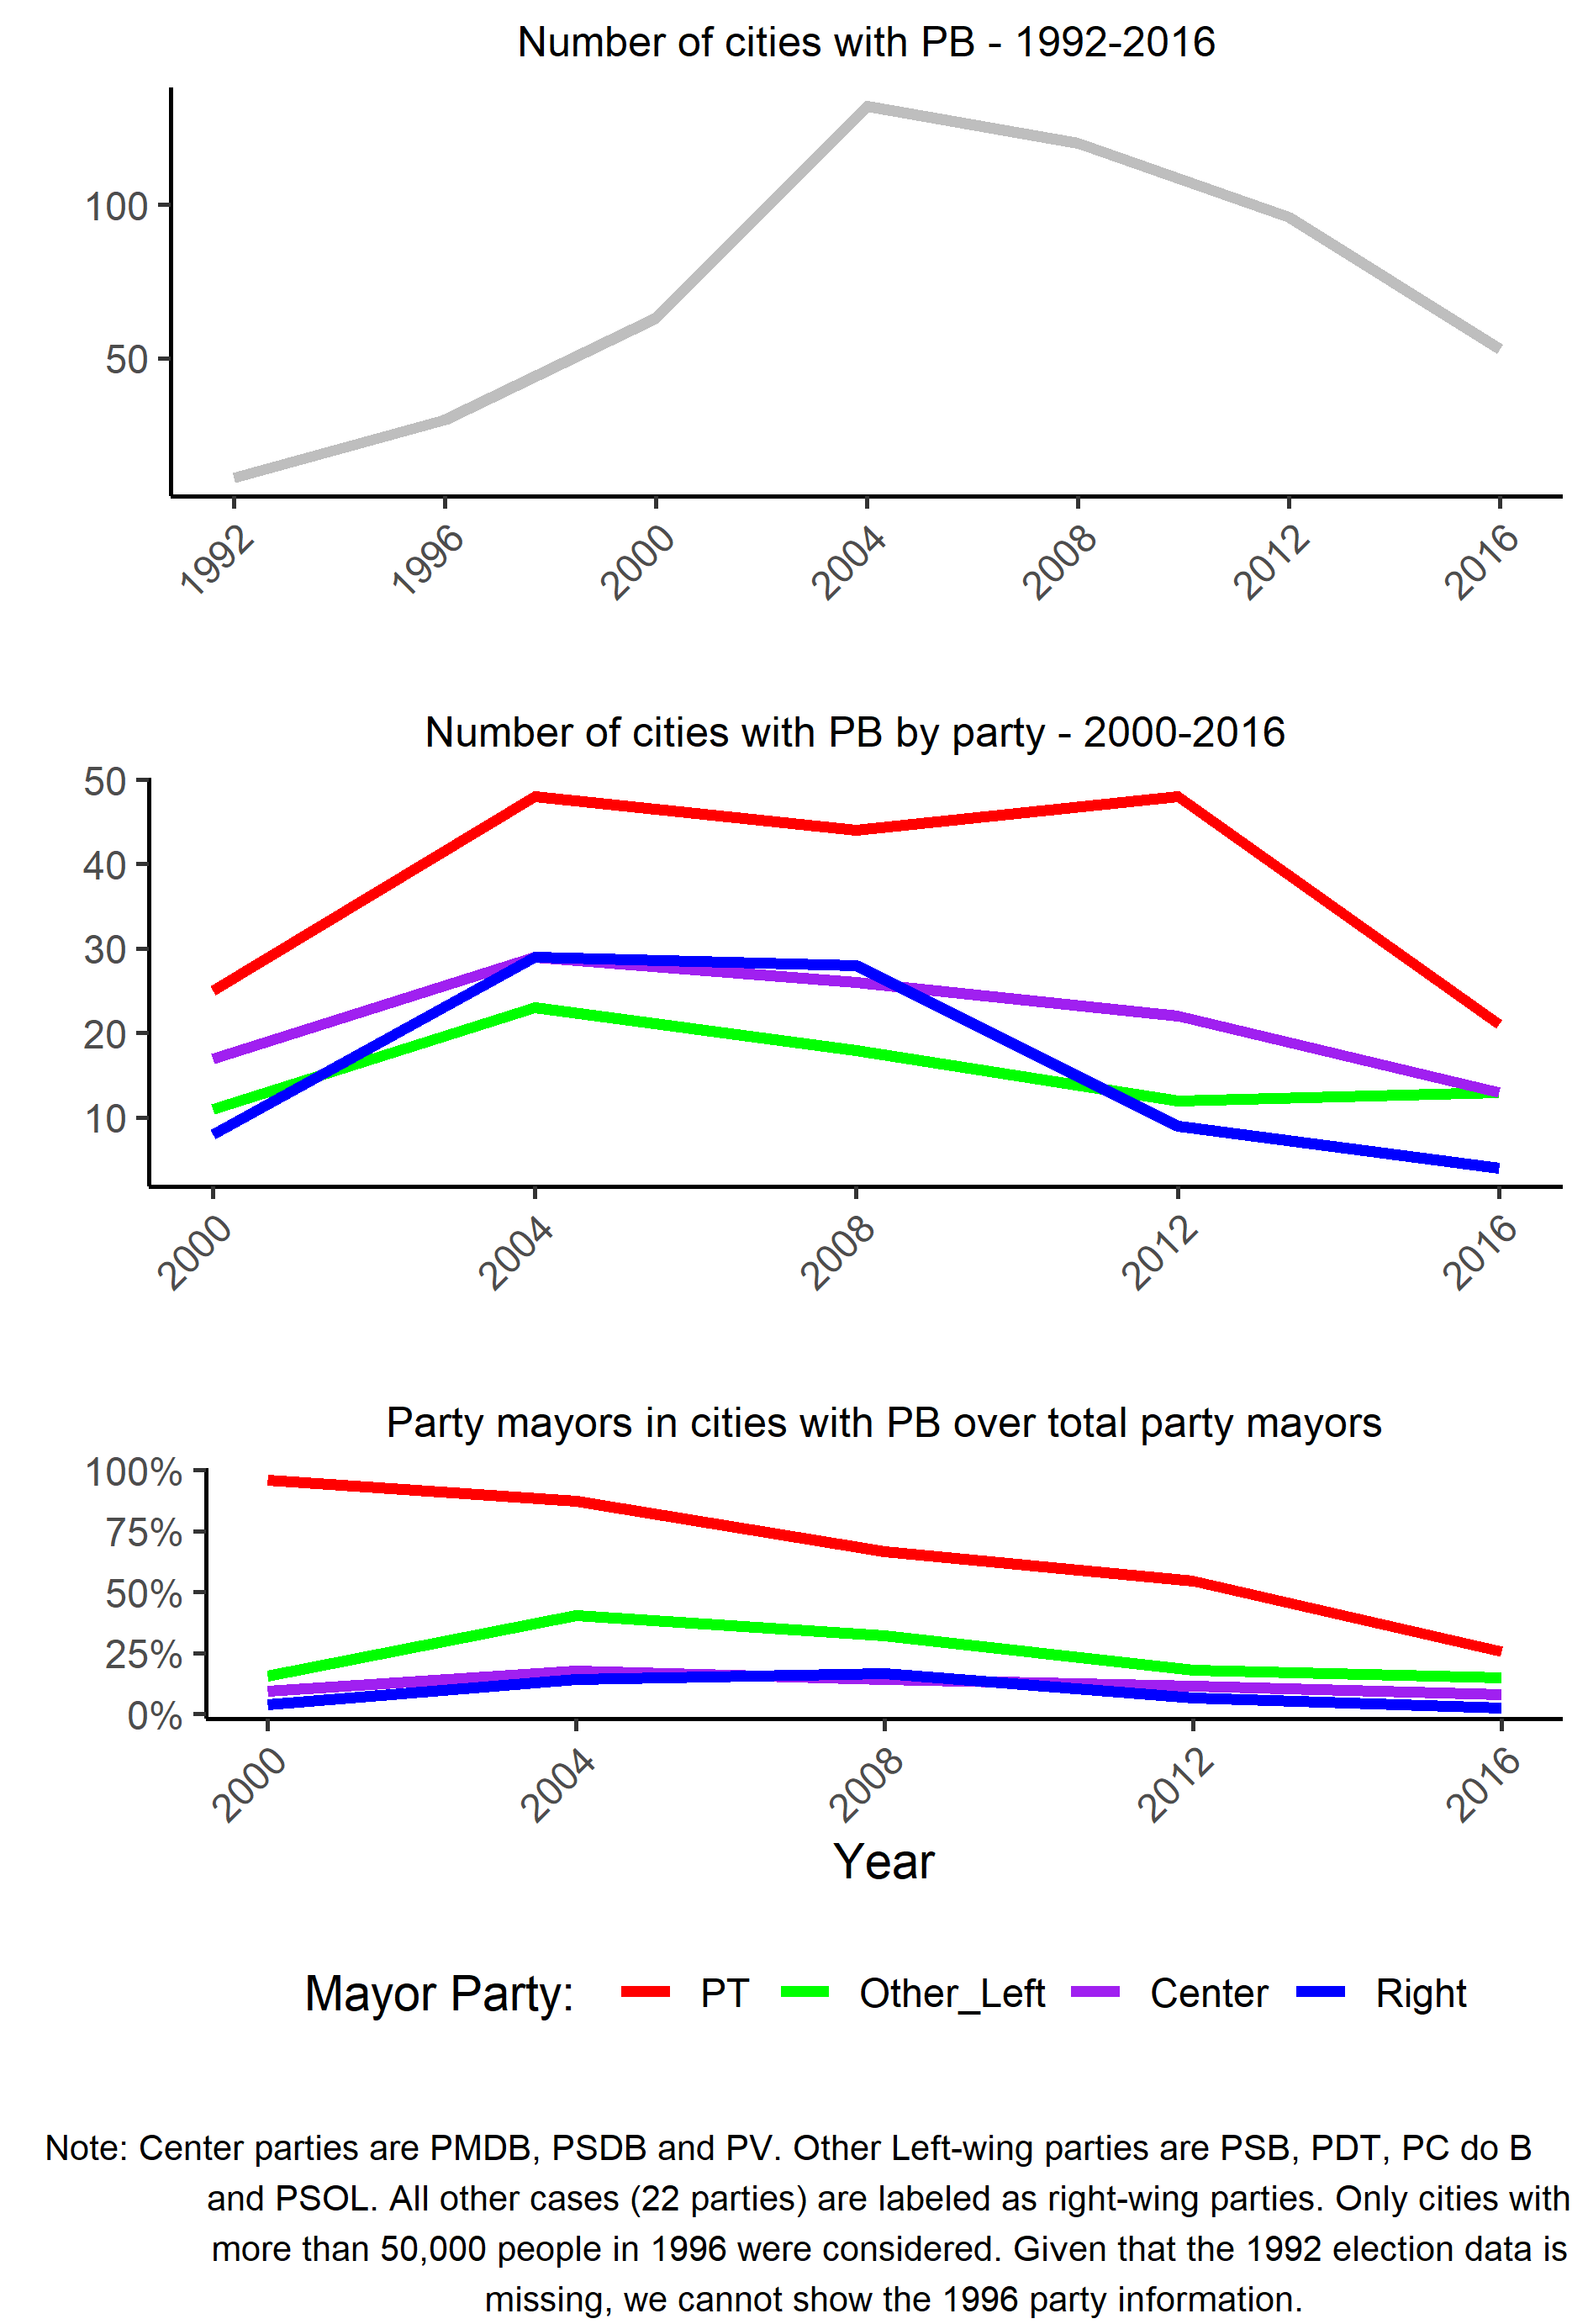

We argue that the set of fiscal rules created during the early 2000s reduced PB effectiveness by diminishing local budgetary discretion and limiting investment expenditure. Due to greater local budgets red tape, local governments had less capability to deliver the city works and improvements defined by citizens over the budget. Faced with such disincentives, the PT switched its party strategy to implement participatory policies. We developed a panel-data analysis model to test this hypothesis. This model is remarkably more accurate (and complex) than those used in previous similar papers on participatory budgeting. Our results show that budgetary variables are relevant both for explaining the first adoption, as well as the continuity of PB implementation. The most significant factors for explaining PB first time adoption by a municipality are: having PT as incumbent, a bigger population and a higher budget per capita. To explain PB continuity, once adopted, the most significant factors are political-administrative continuity, higher budget per capita and a higher investment rate. These findings evince that cities with shorter space for budgetary maneuvers are more likely to abandon PB or even never adopt it.

This article is organized into three more sections and final considerations, in addition to this introduction. The first section presents how scholars addressed the topic and how our argument fills the gap in this debate. Next, we explain how legislation changes generated constraints that reduced mayors' discretions over budget allocation. This also reduced incentives to implement Participatory Budgets, as our cases about two major Brazilian cities (Recife and Belo Horizonte) exemplify. The fifth section details our panel-data model. Lastly, we present our final considerations.

# Participatory Budgeting: diffusion and retrenchment

While the emergence and expansion were the subject of numerous case studies, PB retrenchment in Brazil received little attention. That is not unusual for policy failures and abandonment in general, for both political and technical reasons such as lack of interest in highlighting failures and lack of data due to policy interruption. (Volden 2016). In this regard, Participatory Budgeting seems to follow a common pattern to other policies.

Over three decades, scholarly approach on PB has moved from civil society-centric view to gradually incorporating the role of representative political institutions and actors, such as governments and parties (Souza 2015). Empirical displacements follow the evolution of the object studied. When it was first created, the main concern was about its democratic deepening effects and civic engagement increase. The emphasis on the role of civil society stood out (Santos 1998, Avritzer 2000, Avritzer 2002), although there were already studies that highlighted the role played by the Workers' Party (Abers 1996, Fedozzi 2001). Methodologically, the analyses consisted in case studies of successful pioneering experiences such as the cities of Porto Alegre and Belo Horizonte.

In the following decade, PB cases spread out in Brazil and other countries. Having more variability in the cases, studies began to point out insufficiencies on the explanatory factors such as associative tradition and rulers’ “political will” (Luchmann 2015). Critics on overly normative understandings of civil society role in the democratization of the state also gained visibility (Gurza Lavalle 1999, Dagnino 2002).

Empirically, there are a significant number of comparative case studies, either in the same country or between different countries. The analytical focus is mainly in: institutional design, political and institutional factors that explain PB success or not and possible effects on democracy (Avritzer and Navarro 2003, Luchman 2002, Wampler 2007, Goldfrank 2007, Baiocchi, Heller and Silva 2008).

As PB diffusion slowdown in Brazil, other participatory forms such as Public Policy Councils and Conferences arise and PB studies are incorporated into a more general debate of participatory institutions (Luchmann 2015). Analytically, a relational approach, which states that participatory spaces are mutually constituted by state and social actors, advances against alternative views that valued one or the other (Gurza Lavalle, Houtzager and Castello 2006).

Worldwide, Participatory Budgeting keeps up its diffusion. The complexity of analyzing and comparing the multiplicity of types that arise in different local and national contexts requires scholars to rethink concepts, criteria and typologies that allow comparability between cases (Sintomer et al.2010). Currently, there are important efforts to understand the processes and mechanisms of national and international PB diffusion (Oliveira, 2018). Although PB’s promotion was initially associated with leftist parties (Goldfrank 2007, Sintomer 2008), its international diffusion underwent a process of ideological neutralization as it was embodied in the speech of multilateral agencies such as the World Bank (Ganuza and Baiocchi 2012, Oliveira 2018).

Scholars converge on two sets of explanatory conditions for PB successful implementation and continuity: those related to political actors and institutions, such as parties, city councilors and mayors, and factors related to state capacity, such as budget availability and institutional infrastructure. On the political aspect, comparative case studies point out that the electoral continuity of incumbent political party, the degree of institutionalization of the opposition party, as well as the established relationship between executive and legislative branches are crucial for PB continuity in a given municipality (Dias 2002, Nylen 2003, Souza 2011, Borba e Luchman 2007, Goldfrank 2007).

On the state capacity aspect, Goldfrank (2007) argues that the success of the Participatory Budget depends on greater administrative decentralization and, consequently, greater mayor discretion on budget allocation and resource availability. Luchmann (2002) also highlights resource availability and government infrastructure as key institutional elements. Nonetheless, institutional factors are considered important. Pires and Martins (2011) note that, at least in Brazil, there are no studies that analyze in-depth PB in its technical budget-financial dimension.

Quantitative analyses have tried to test both political and state capacity conditioning factors (Wampler 2008, Spada 2014). Such efforts were limited, partially due to the low reliability of the data available, but there are some examples on the diffusion of both.[3] Wampler (2008) analyses the effects of the PT as incumbent, Left Party Presence in the Legislator, Civil Society Networks, HDI, Region (South), and Investment Expenditure. The only significant factor for explaining diffusion in his work is the PT as incumbent party. Spada (2014) tests the effects of having the PT as an incumbent party, proximity with other cities with PB, the availability of resources, and the political vulnerability of local government. He reinforces that having the PT as incumbent is the key factor for PB diffusion. As the reasons for its retrenchment remain inconclusive in his model, he suggests that it might be related to changes in the political strategy of the Workers Party, motivated by the election of Lula for Federal Office in 2002, following Hunter’s (2010) argument.

Thus, scholars have not yet addressed the real reasons for the retrenchment of this once “showcase” policy. A policy may be considered a failure either for political reasons, such as public loss of support, or for technical reasons, such as little effectiveness in the problem it is meant to address. In either case, policy failures are expected to be abandoned (Volden 2016) In our view, it is not the change in PT national strategy that explains PB abandonment. If Participatory Budgeting continued to promote positive political returns, on either technical or political grounds, one would expect the PT and other political parties to continue investing in it, including the creation of federal incentives. The decline in PB adoption by all political parties (see figure 1), regardless of ideology (left-right) or positioning in relation to the government (situation-opposition) suggests other institutional mechanisms operating as a more plausible explanation for the gradual abandonment of the policy.

Our study addresses this gap by arguing that increasing fiscal constraints led to gradual policy abandonment, as local governments were unable to deliver city works that citizens had deliberated previously, leading to expectation frustration and the inefficacy of the participatory instrument.

# Increasing difficulties in implementing PB: insights from Recife e Belo Horizonte

What has changed for an awarded program to become increasingly difficult to be properly executed by local governments? During the late 1990s, there were gradual changes in fiscal regulation that altered the budgetary reality of local government, which finally consolidated into the Fiscal Responsibility Law (Lei de Responsabilidade Fiscal, Lei Complementar 101/2000, also known as LRF). The focus of the LRF is to ensure that all the federation's entities, especially states and municipalities, follow controlled and sustainable fiscal parameters.[4]

Despite its positive effects on state and municipal fiscal balance, it had an undesired negative impact on local investment availability. Menezes and Toneto Jr (2006) demonstrate that, between 1998 and 2004, there was a sharp decline in investment expenditures of 21.7% as a direct consequence of the LRF.[5] The authors also show that personnel and current expenditures were not affected, and that debt interest and charges and loan amortization expenditures increased. Schettini (2012) argues that in the event of a budget imbalance, the City Hall tends to make an adjustment by reducing expenditures against the option of increasing revenues. As most of the local budget is comprised of mandatory expenditures, the cut off has to be made on discretionary ones, such as investment.

Another federal regulation that had a great impact over local government fiscal autonomy during the 1990s was that of constitutional provisions of social policies, particularly health and education.[6] Such regulations established compulsory resource transfers from federal to local government, conditioning such transfers to the follow up of national policy guidelines and the binding between such revenues and its expenditures on specific social policies. Thus, Brazilian federalism moved towards a format of decentralization of social services offered, which are in charge of the local governments, and a centralization at the federal level of fiscal policy as well as basic operation norms and guidelines for social policies (Arretche 2012, Guicheney, Junqueira and Araujo 2017).

Therefore, the fiscal and budgetary reality under which municipalities were at in the beginning of the 1990s is significantly different from that of the early 2000s. Although there has been an increase in the period, both in own taxes and transfers grants (Leite and Peres 2010), the binding among revenues and expenditures and the inertial increase in expenditures (Peres and Mattos 2017), has significantly reduced the local executive's room for budget maneuvers. This means that the current situation of local governments is of high budgetary rigidity, in which there is not only a large volume of income, but also a large volume of compulsory expenditure. Thus, even within a balanced budget, a local government may have little room to manage its discretionary investment budget (the only type of budget resource deliberated in PB process).

According to our interviews, such fiscal changes had been felt by PT leaders and bureaucrats. There was a diffuse perception among them of increasing difficulties to implement citizens’ PB demands, albeit not explicitly in the party documents[7]. They would argue that resources allocated via PB were not perceived as effective to "respond to the demands of the population" because of "bureaucratic obstacles" that generated delays in the completion of the work beyond the fiscal year or even beyond the administration of the incumbent mayor. Despite the adequate fulfillment of the citizens’ demands, the priorities defined in the PB process were only properly executed when they were simple projects, such as street paving and sidewalks. Any major project that demanded land expropriation or for which there was no available budget - and therefore demanded external financing from the state, federal government or through international means - ended up taking longer than the duration of the administration’s period for its completion.

Fiscal changes were consolidated in the 2001 LRF Law. As municipal and national elections are held interleaved, Lula won National office in 2002 and the following municipal elections, after these two landmarks, were held in 2004. That is exactly the inflexion moment in which PB adoption begins to decline, as shown in figure

Recife and Belo Horizonte are two cases of relatively successful and long-term adoption of Participatory Budgeting in Brazil in state capitals and amongst the richest cities in Brazil. They illustrate the increasing limitations of PB adoption in Brazilian local governments. Recife's PB started in 1993, during the administration of Jarbas Vasconcelos of the PMDB (center-right), but gained greater visibility as a new methodology that significantly expanded the number of participants and the volume of new investments by the administration of João Paulo (PT) in 2001 (Wampler 2007, Wampler 2008). [8] The PT remained for three consecutive administrations in charge of this city hall, succeeded in 2013 by the current mayor Geraldo Júlio (PSB). In 2013, when Geraldo Julio (PSB) took office, Recife’s PB had 1,045 overdue demands, for up to 14 years delayed. Instead of interrupting the program, it was refashioned in much more flexible terms:

*In order to avoid the excess of demands, when he instituted “Recife Participa,” Geraldo determined that the works debated may or may not be adopted by the PCR [Recife City Hall], as they were not mandatory. [9]*

Thus, PB was adopted continuously by five consecutive administrations of different parties (PMDB, PT and PSB). Despite the PT’s high political effort to keep the program, Recife’s PB has always had difficulties in its execution due to the scarcity of resources for investments, as well as an inefficient bureaucracy (Wampler 2007). The author described the program as a good funnel for population demands, but with a low capacity to respond to them.

Belo Horizonte’s PB is as old as Recife’s. It also began in 1993 during Patrus Ananias’ term (PT). Since then, the PT and PSB alternated in power at the city during six consecutive elections, always running together as either mayor or vice-mayor. Therefore, there was a political continuity and maintenance of the Participatory Budgeting program. As Márcio Kalil (PHS) took office in 2016, this party alternation cycle was interrupted, but PB implementation was kept until present day. Unlike Recife, Belo Horizonte is a city with greater financial capacity for investments, as well as a better-qualified bureaucracy (Wampler 2007). PB’s limitations in this case regards to its diminishing political relevance, as the resources share deliberated by the citizens were gradually reduced and bureaucracy-chosen share increased. Despite such differences, the city faces the same issues regarding delays on work execution, as seen in the report below:

*Belo Horizonte has an estimated amount of R$ 1 billion* [US$ 267 million] *in delayed works approved by the Participatory Budgeting (PB). Without own resources to complete the 441 interventions, which would account for 9% of the total Budget for 2017 (R$ 11 billion) [US$ 2.9 billion], the City Hall will start looking for loans. Such resources, however, can only be added to next year’s budget. Meanwhile, there are projects approved by the population in 2001 that have not yet been fulfilled. [10]*

The cases show obstacles local governments face: 1) the low availability of investment resources at the local level, even in the biggest cities; 2) inefficient administrative procedures and low state capacities to process citizens’ demands (low rate of drafted projects, expropriation and judicial pending); 3) PB design limitations, which allow the deliberation on works, without the budget availability for such, generating a snowball effect of unmet demands.

Except for the last issue, related to PB design, all the budgetary and administrative obstacles are not related to any party in particular, but are common challenges for anyone aiming for City Hall. The challenges for the execution of local projects lead to a gradual discredit of the Participatory Budgeting program and the government itself. Moreover, the low capacity for implementation of the priorities deliberated by the population pushed towards its reformulation in more flexible frameworks: reducing the amount of resources to be discussed by the population or considering citizen deliberations as non-mandatory and, in fact, as just a suggestion.

# Panel Data Analysis

**Hypothesis**

Our hypothesis is that local governments gradually stop adopting PB because of increasing fiscal and administrative constraints. The set of fiscal regulations created throughout the 1990s directly affects PB effectiveness because it limited the local fiscal discretion by reducing investments expenditures (public projects)[11] and increasing budgetary rigidity, through revenue and expenditure binding. If our hypothesis is correct, we should expect our model to predict that municipalities that have higher investment expenditures are more likely to adopt and continue PB. The PT as the incumbent party in a given municipality increases the probability of adopting PB during the whole period, with reduced effects after it takes Federal Office (2003).

## 

## Model

Our model tests the probability of adoption and continuity of PB in Brazilian municipalities, having as a baseline Spada’s model (2014), which incorporates most of the variables described by qualitative and quantitative literature (Dias 2002, Nylen 2003, Wampler 2008, Souza 2011). From this baseline, we add other variables to address the issue and also completely reformulated the functional form of the model to deal with the interactive and temporal nature of the variables. For example, some variables don’t influence the chance of PB if in the previous period the city don’t have PB (adoption), but the same variables are significant if the city already have PB (continuity). As a result, our model became much more complex, but also more accurate than previous efforts.

We grouped our model covariables into three sets: economic, demographic and temporal adjustment variables[12]. First, to verify our hypothesis, we use as financial variables the municipal budget per capita and the rate of investments (in relation to the total budget). These variables have a strong and consistent effect of predicting the chances of a municipality adopting PB[13]. Second, we add population in its natural logarithm as a control variable, for PB has greater presence in large cities, regardless of the mayor’s party. As population correlates to a series of factors,[14] ignoring this variable may bias the model. We use interactive models to demonstrate that left and right parties have a different probability of adopting PB according to population size. Third, we model the path dependence, or temporal adjustment variables. We chose to work with interactive modeling, using the complete sample and interacting the existence of PB in the previous period with highly significant variables to explain the chance of continuity or abandonment. For descriptive statistics of the variables, see Table 1, in the Appendix.

The analysis follows a panel data model with fixed effects of time. The model follows the following basic reasoning, with the respective matrices of variables detailed below:

*𝐸(PB𝑖,t) = 𝛼 + 𝛽1PATHi,t + 𝛽2𝑃𝑂𝐿i,t + 𝛽3𝐸𝐶𝑂i,t + 𝛽4POPi,t + 𝛽5 INTi,t + 𝛽6 FEi,t + ɛi,t*

1. PB Variable: The dependent variable is a dummy, with value one, when the municipality adopts PB for that term, and zero, when not adopting the program. For cases valued as one, the PATH variables inform if there is a new adoption or a continuation of the program already adopted in previous administrations.

2. Path Variables (PATH). To evaluate the effect of path dependence, we use two variables. The first is whether the municipality had PB in the previous period or not; that is, the lagged dependent variable. The second is the amount of accumulated periods during which the municipality adopts PB. The assumption of this last variable is that the longer the policy stays in the city, the more difficult it is to remove it.

3. Political variables (POL). These variables include partisan control variables, political continuity and political vulnerability variables. First, for partisan control variables, we use a dummy variable that has value 1 when the incumbent mayor is a PT partisan[15]. We also insert a variable indicating whether the incumbent is from a left leaning party (PT, PSB, PDT, PCdoB and PSOL[16]) to control for the effect of the left in general (not just PT) on the probability of PB adoption. Finally, we control for different PT behavior before and after it takes federal office in 2003, by using a dummy that has value 1 for the periods after 2003.

Second, we control for political continuity effects. For that, we use a dummy that has value 1 in cases where there is party continuity, and another dummy that takes value 1 if there is a mayor continuity (re-election). These variables may overlap, but there are cases in which the mayor has a successor from the same party (because they cannot be reelected anymore due legal limitation of one re-election, for example) or cases in which mayors switch parties (and reelects themself). If a party or a mayor adopts PB in the first term, we expect that he is more likely to also do so in the second term.

Third and finally, we control for the mayor's political vulnerability, measured by the runner-up over the winner’s ratio vote and by the percentage of City Council seats (legislative body) occupied by the City Hall incumbent party.

4. Economic and Fiscal Variables (ECO). Our hypothesis - that the availability of investments correlates with the occurrence of PB - is measured by the investment rate (total investment over total expenditure). We also use the municipal public budget per capita (in its natural logarithm) as a control variable, for there might be other discretionary expenditures not captured by our first variable and because cities with larger budgets tend to have better staff and higher administrative capacity.

5. Population or scale variables (POP). We use the natural logarithm of the population as a control variable. From the descriptive statistics, larger cities adopt PB proportionally more than smaller cities, but it is not clear how much this effect is due to budget (also correlated to population size).

6. Interactions (INT). We present three types of interactions terms. The first set of interactions uses the lagged dependent variable to explain which political and financial factors are the most important to explain PB’s adoption and continuity. For political continuity, we use two interactions of PB lagged variables: mayor and party reelection. Regarding financial variables, also another two interactions with PB lagged variable: investment rate and total budget per capita (log). The second set of interactions uses the population (log) to check how party behavior change according to size of the city. We interact population (log) with the following variables: PT mayors, left leaning mayors and PT mayors after 2002. Finally, the last interaction term is between total budget per capita (log) and investment rate, to check if the amount of investment is relevant and not only the share[17].

7. Fixed Effects (FE): These are dummies for each analyzed period. The fixed effects model aims to capture influences not explained by the model variables in a certain period. That is, how much unknown factors explain changes observed in a specific period. The database contains four periods: 1997-2000, 2001-2004, 2005-2008 and 2009-2012. The first two refer to periods of PB diffusion and the last two are periods of PB retraction.

We used two models in this study, derived from the basic equation above. The first one uses all the terms of the equation presented above, except the interactions. This model is more easily interpreted by simply looking at the coefficients on Table 2 (see appendix). The second model includes the interactions. As the interpretation of interactive models is not very intuitive (Brambor, Clark, Golder 2006), we use a graphical approach to present and discuss the results (for the complete regression table, see Table 2, in appendix). Both for the non-interactive and for the interactive models, we ran a Fixed Effects Linear Predicted Model (LPM), which simply consists of the ordinary least squares method on a binary dependent variable. We also tested the same variables with the Logit model (not shown), whose results did not differ significantly from the LPM.

## Data Sources

Our database was drawn from four different sources[18]. Our dependent variable comes from the Brazilian Participatory Budgeting Census for the 1989-2012 period[19] (Spada 2012), which unified and updated available data on existing Brazilian Participatory Budgeting (Ribeiro and Grazia 2002, Avritzer and Wampler 2004). The variable is a dummy that informs about the existence or not of Participatory Budgeting in a municipality, for each administration period. Only municipalities with more than 50 thousand inhabitants in 1996 are considered. The data uses as reference the existence of PB in the municipality during the three years preceding the reference year, which is always the end of the political term. For example, the year 2000 refers to mayors elected in 1996 for the 1997-2000 term.

Our political variables come from official electoral data from the Brazilian Superior Electoral Court (TSE), pre-treated by CEPESP Data.[20] For financial variables, we used dataset provided by the National Treasury Department of the Ministry of Finance (STN/MF) called Brazil Finances: Accounting Data of Brazilian Municipalities (FINBRA).[21] All data were deflated, using 2015 as reference year. Finally, for the demographic data (population) we used the Brazilian Statistics and Geography Institute (IBGE) data, pre-treated by the Applied Economics and Planning Institute (IPEA) data.[22] For all financial data, we use the average of the four years period to avoid distortions caused by atypical economic behavior in a specific year.

## Main results

Our results demonstrate that the most significant factors for explaining a PB adoption by a municipality at least once are having PT as incumbent party, a bigger population and a higher budget per capita. The factors that stood out to explain PB continuity are budget per capita, political-administrative continuity and a higher investment rate. These results are consistent with our initial hypothesis, but they add more complexity to the issue. The investment rate is relevant only for explaining PB continuity, not its first-time adoption, which budget per capita explains better. Population is *per se* a relevant explanatory variable, and in interaction with political parties, shows the existence of a different behavior according to the size of the city.

To analyze the interaction effects of the lagged dependent variable, population and the other variables in our complete model, we use a graphical approach, since interpreting interactive models from regression tables is not intuitive. In these graphs, the vertical axis displays the expected values of the dependent variable, *E(PBi,t  = 1)*, that is, the chance of any city adopting PB in a given year. The horizontal axis displays selected independent variables in interaction. All other model variables not displayed in the graph are in its mean values. All graphs also show the confidence intervals of 95% of the estimates. The values were calculated using Zelig R Package (Choirat et al, 2017). The complete interactive model estimates table is available in the appendix (Table 2). The main findings of this study are:

**PT (and the left) as incumbent.** As expected and similarly to other scholars’ results (Wampler 2008, Spada 2014) having PT as incumbent is a strong predictor of PB adoption and political continuity as well, with a significant drop after 2003. The PT effect in the non-interactive model must be interpreted by combining two variables: the PT and the PT after 2003. For before 2003, having the PT in charge of a prefecture increases its probability of adopting PB by 78% (PT as incumbent: *β = 0.68*, and left party as incumbent: *β = 0.1*). However, the variable PT as incumbent after 2003 presents a negative coefficient (*β = -0.43*). As these variables derive from each other, they must be considered together for proper interpretation: thus, after 2003, a PT prefecture still has a 35% higher probability of adopting PB in comparison to the other parties. That is, even if there is a significant drop, PT remains an important predictor of PB adoption.

**Population.** Looking at the population variable, it shows the tendency of PB to occur more often in large cities. In fact, the mere descriptive statistic shows that 54% of Brazilian municipalities with more than 500,000 inhabitants have adopted PB at least once, a number that falls sharply as the population size decreases. This may help to explain how PB became a famous showcase program, even though it does not have a massive diffusion in Brazilian municipalities. Before 2003, PT also concentrated its presence in medium and large cities, a fact that changes after it takes federal office, when the party begins to spread to small towns. Figure 2 displays the interaction between the PT and the municipal population, before and after 2003. It shows that the PT effect decreases in small and medium-sized cities. In cities with more than 1 million inhabitants, PT influence over PB adoption remained at a level of 80% for the whole period. In figure 3 we have extended the analysis by comparing the chances of PB adoption in cities with PT mayors, other left-wing mayors, and centrist or right-wing parties. It can be seen that the OP is strongly correlated with leftist parties, especially in big cities.

**Figure 2 – Expected Values of PB with PT incumbent mayor**

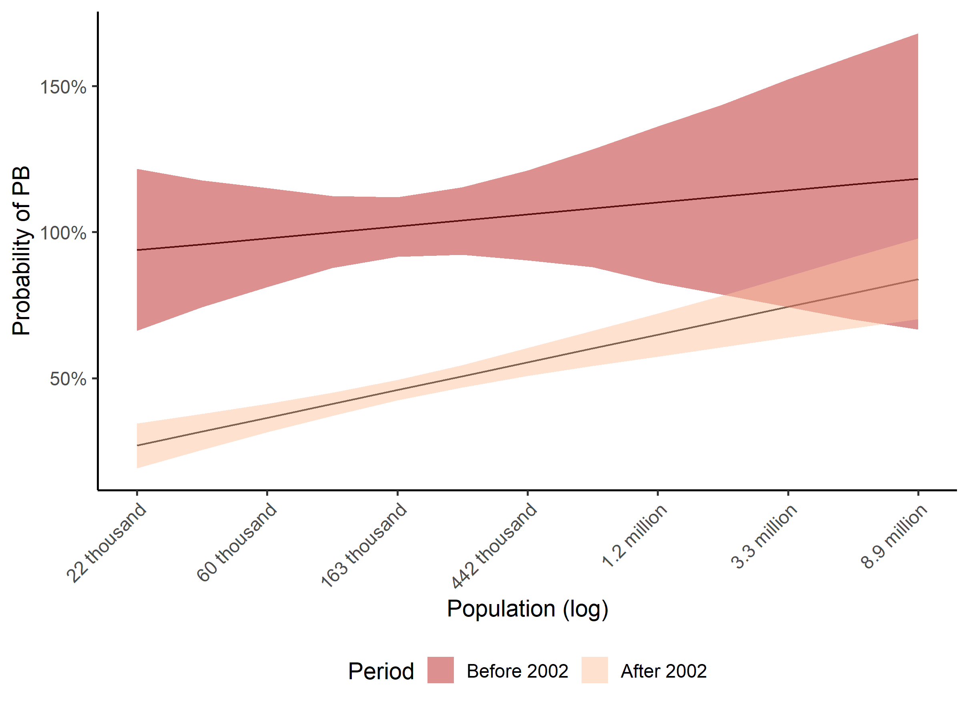

**Figure 3 – Expected Values of PB, Demography and Ideology**

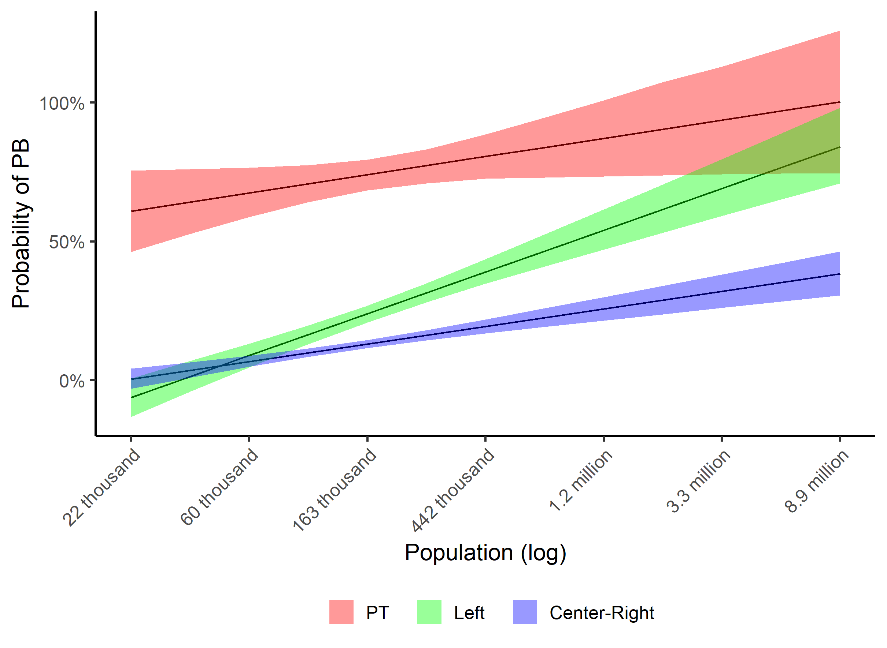

**Political Continuity:** The political-administrative continuity analysis considers three variables: the continuity of the party and the mayor, and their interaction with PB adoption in the previous term (lagged dependent variable). We present thus four scenarios: (a) re-elected mayors who did not adopt PB in their first term; (b) re-elected mayors adopting PB in their first term; (c) Same party succession where the previous administration did not adopt PB; and, (d) Same party succession where the previous administration adopted PB. Figure 4 shows that re-elected mayors or parties who did not adopt PB in their first term, have a very low chance of adopting PB in the following one: around 6% and 12%, for mayors, 11% and 18%, for parties, with 95% confidence. The situation changes when the previous administration already adopted PB. In this case, the re-elected mayors have between a 29% and 41% chance of continuing PB, and a same party successor, between a 29% and 44% chance of keeping everything more constant. That is, even in the case of political continuity, the tendency of mayors is to abandon PB after the first adoption in more than half of the cases[23]. Another important variable to analyze is the effect of accumulated years of PB adoption. As expected, the longer the program is implemented in the municipality, the greater its tendency for continuity: an increase of about 6.5% points in the chances of continuity for each accumulated year, regardless of changes of party or mayor.

**Figure 4 – PB and administrative continuity**

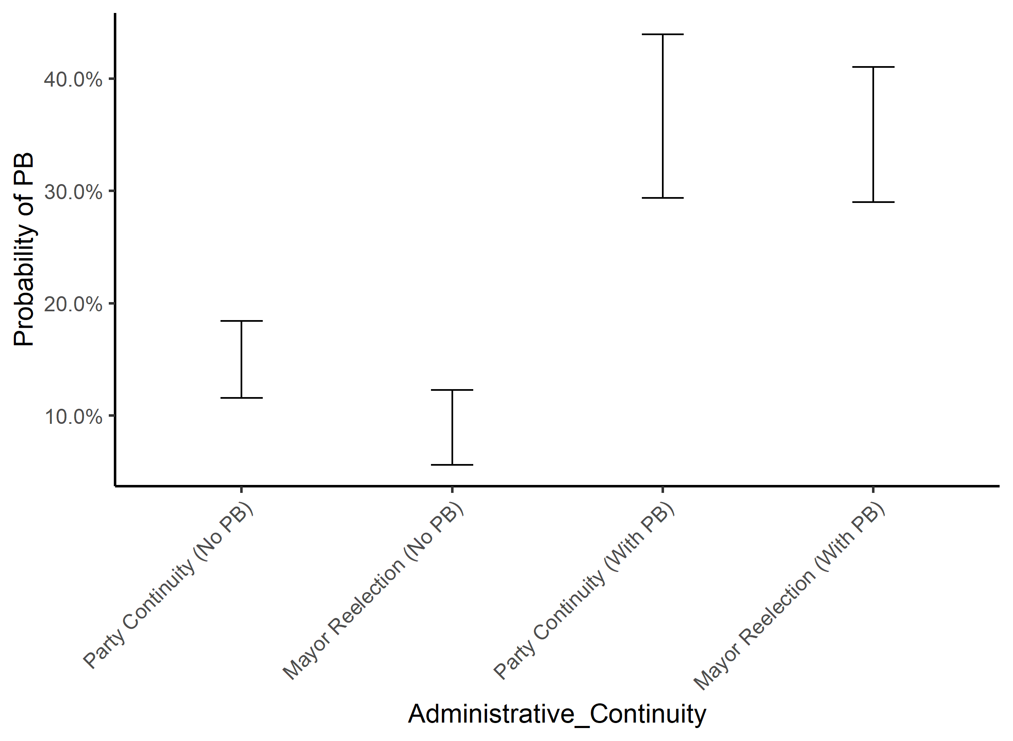

**Financial Variables:** The results show that the budget per capita is an important predictor for PB adoption and continuity. As population and budget tend to correlate - that is, the more inhabitants, the higher the budget - we use budget per capita (log) as a measure, which allows us a better comparability of budget availability. Figure 5 displays PB adoption probability through the interaction of budget per capita (log) and the lagged dependent variable, showing separately the effect in the case of first-time PB adoption, *E(PBi,t = 1| PBi,t-1) = 0*, and the effect of PB continuity, that is, PB adoption in a previous administration, *E(PBi,t = 1| PBi,t-1) = 1*. In the background, there is a grey histogram with the budget per capita (log) distribution. The figure shows that the increase in budget per capita increases the chances of a municipality to adopt PB. For continuity, the slope of the curve is slightly lower, but it is still significant. This finding corroborates our hypothesis that better fiscal capacity increases the chances of a city apply PB.

**Figure 5 – Estimated effects of Budget per capita on PB probability**

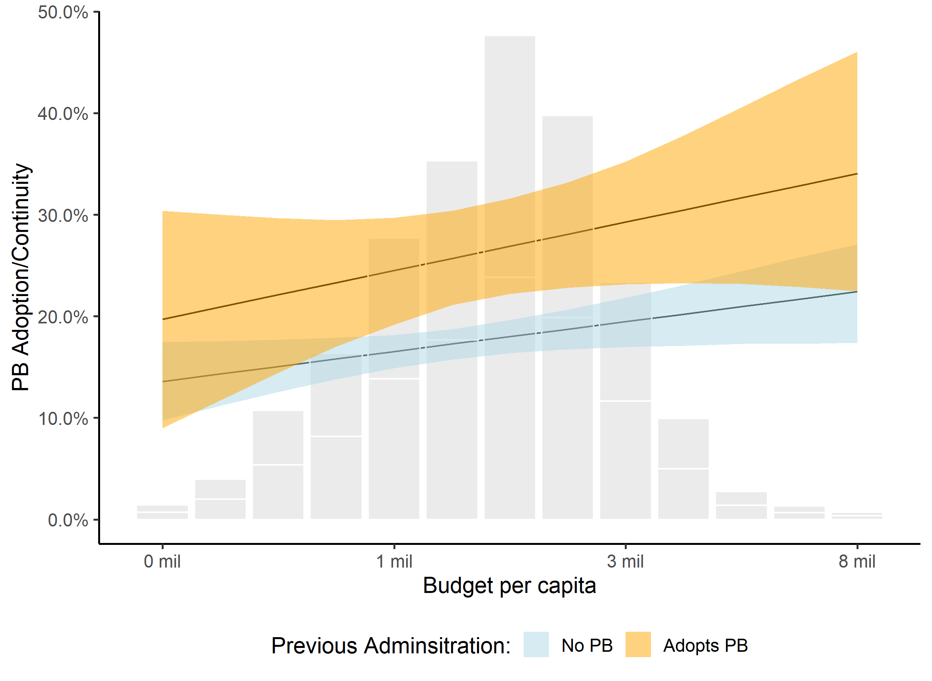

The investment rate, on the other hand, presents a remarkably difference in behavior between municipalities which have previously adopted PB and which don't, as shown in Figure 6. Municipalities that have already adopted PB have a greater chance of continuing to adopt the program if they have larger investment expenditure. This finding is consistent with previous qualitative research, which focused on municipalities that had already adopted PB and reported that the lack of investment resources availability made the policy less attractive. However, for cases where there is no previous PB adoption, the is no significant correlation between investment rate and the probability of adopting the program.

**Figure 6 – Estimated effects of Investment rate on PB odds**

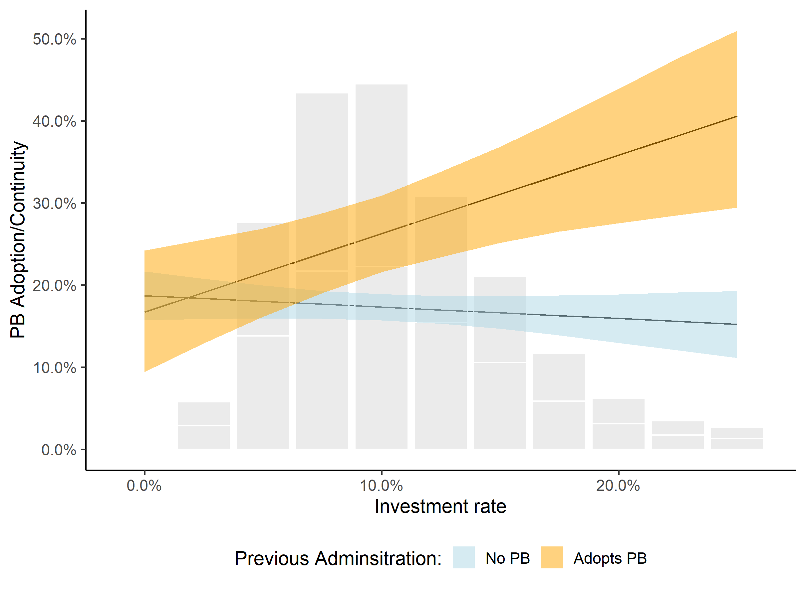

Our model presents important findings that confirm our initial hypothesis that municipalities that have more budget availability are more likely to adopt and continue PB. The data shows that municipalities with higher budgets per capita are more likely to adopt and continue PB and investment rate is an adequate predictor for the continuity of the program. In this way, we can affirm that, increasing budgetary rigidity contributed to the decline of PB, both by reducing its effectiveness and imposing constraints on its continuity, as our qualitative research had already suggested.

In addition to demonstrating that financial variables are key to understanding the process of a declining PB adoption rate, our model innovates by adding interactive analysis and incorporating the population and administrative continuity variables. Unlike in the analysis by Spada (2014), apart for party and political continuity variables, other political variables did not appear as statistically significant in any of the several models tested.

# Final considerations

In the early 1990s, Brazilian municipalities had apparently smaller budgets but greater room for budgetary maneuver, for there were fewer fiscal regulations (and thus, local governments largely used resources by creating future debts) and less revenue and expenditure linkages. This scenario changes drastically with the subsequent set of fiscal regulations, notably the LRF. Besides its explicit scope for promoting financial equilibrium of the Federation, it also had some unintended consequences, such as decreasing local investment expenditures. In addition, social policies legislation, in order to guarantee the right for education and health services, created revenues and expenditures linkages for federal transfers to local government, which also increased local budgetary rigidity.

By the time the PT is elected to federal government, PB was the party’s main showcase policy, adopted massively by its prefectures (93% of PT prefectures adopted PB for the period of 1996-2000 and 87.5% for the period of 2000-2004). Taking Federal Office represented new policy opportunities and political priorities, at the same time during which PB cases began to not have the same positive results as before.

The distributive conflict for budget resources among the various interested actors in the executive and in the legislative increases. As our examples showed, the PB process faced years of delay in the execution of the works approved as priority, either due to a lack of resources or low local state capacity, making PB less effective and less politically attractive, either for the population or for the Mayor in office. In this case, either the program is reformulated in a more flexible framework or the amount deliberated by the population is reduced.

In this context of strong budgetary rigidity and scarcity of resources for new investments in municipalities, the maintenance of Participatory Budgeting as a local participation policy would require some type of regulation or federal induction policy. Such federal induction mechanisms are common and occur in cases of Social Policy Councils with high dissemination (Gurza Lavalle and Barone 2019, Mayka 2018), or even in the case of PB in Peru, where there is a national law that obliges all municipalities to adopt Participatory Budgeting (Oliveira 2018). In the absence of other political or fiscal incentives, the program follows a trajectory of inertial continuity, being gradually abandoned.

In summary, we argue that due to gradual changes in fiscal legislation, which have led to a greater rigidity of municipal budgets, as well as administrative obstacles to the execution of works, the effectiveness of the decisions made by the population on the budget has been reduced. In such a scenario, and without creating new institutional incentives for PB, new adoptions were discouraged and only long-term successful cases tended to continue. As the PT stops promoting PB, and seizes other participatory policy alternatives in the federal government,[24] such shift intensifies PB retrenchment.

**Bibliography**

Abers, Rebecca Neara. 2000. *Inventing Local Democracy: Grassroots Politics in Brazil*. Boulder: Lynne Rienner. v. 1. 267p.

Avritzer, Leonardo and Zander Navarro (eds.). 2003. *A inovação democrática no Brasil: o orçamento participativo*. São Paulo: Cortez.

Avritzer, Leonardo and Brian Wampler. 2004. “Públicos participativos: sociedade civil e novas instituições no Brasil democrático.” In *Participação e deliberação: teoria democrática e experiências institucionais no Brasil contemporâneo*. ed.Vera S P Coelho and Marcos Nobre. São Paulo: Editora 34, 2004.

Baiocchi, Gianpaolo.2003. *Radicals in Power: The Workers’ Party (PT) and Experiments in Urban Democracy in Brazil*. London: Zed Books.

Barberia, Lorena G. and George Avelino. 2015. “Fiscal Discretion and Elections in the Brazilian States.” In *2015 Midwest Political Science Association National Conference*, Chicago, IL.

Bezerra, Carla de P. 2014. “Do poder popular ao modo petista de governar: mudanças no significado da participação para o Partido dos Trabalhadores.*”* Msc thesis, University of São Paulo.

Bezerra, Carla de P. 2018. “Os sentidos da Participação para o Partido dos Trabalhadores (1980-2016).” *Revista Brasileira de Ciências Sociais* (forthcoming).

## Boulding, Carew and Brian Wampler. 2010. “Voice, Votes, and Resources: Evaluating the Effect of Participatory Democracy on Well-being.” *World Development* vol: 38 (1) pp: 125-135.

Brambor, Thomas, William Roberts Clark and Matt Golder. 2006. *Understanding Interaction Models: Improving Empirical Analyses*. Political Analysis 14 (1): 63-82.

Cabannes, Yves. 2004. “72 frequently asked questions about participatory budgeting.” Nairobi, Kenya: UN Habitat Global Campaign on Urban Governance.

Choirat, Christine; Honaker, James; Imai, Kosuke; King, Gary; and Lau, Olivia (2017). *Zelig: Everyone's Statistical Software*. Version 5.1.4.90000, URL:

<http://zeligproject.org/> .

Dias, Márcia R. 2002. *Sob o signo da vontade popular: o orçamento participativo e o dilema da câmara municipal de Porto Alegre*. Belo Horizonte: Editora UFMG.

Fedozzi, Luciano. 2000. *O poder da Aldeia: gênese e história do orçamento participativo de Porto Alegre.* Porto Alegre: Tomo Editorial.

Fedozzi, Luciano, Kátia Cacilda Pereira Lima and André Martins. 2014. “Desigualdade na ampliação das inovações participativas: características dos municípios com Orçamentos Participativos no Brasil. ” *38 Encontro ANPOCS*.

Goldfrank, Benjamin. 2007. “The Politics of Deepening Local Democracy: Decentralization, Party Institutionalization, and Participation.” *Comparative Politics* 39(2): 147–68.

Goldfrank, Benjamin. 2012. *Deepening Local Democracy in Latin America: Participation, Decentralization, and the Left*. University Park: Pennsylvania State University Press.

Gonçalves Sonia. 2014. The Effects of Participatory Budgeting on Municipal Expenditures and Infant Mortality in Brazil. World Development vol: 53 pp: 94-110.

Gurza Lavalle, Adrian and Leonardo Barone. 2019. “Councils, Associations, and Inequality.” In *Paths of Inequality in Brazil - A Half-Century of Changes*, ed. Marta Arretche. Springer International Publishing. p. 25-44.

Guicheney, Hellen, Murilo Junqueira and Victor Araujo. 2017. “O debate sobre o federalismo e suas implicações para a governabilidade no Brasil (1988-2015). ” *Revista Brasileira de Informação Bibliográfica em Ciências Sociais - BIB*, v. 83, p. 69-92.

Hunter, Wendy. 2010. *The Transformation of the Workers' Party in Brazil, 1989-2009*. New York: Cambridge University Press.

Leite, Cristiane K and Ursula D Peres. 2010. “Lei de Responsabilidade Fiscal, federalismo e políticas públicas: um balanço crítico dos impactos da LRF nos municípios brasileiros. ” In *Estado, instituições e democracia: república*, ed. Alexandre Cunha, Bernardo Luseni and Maria de Aquino. Brasília: Ipea, v.1.

Lüchmann, Lígia Helena Hahn. 2014. “25 Anos de Orçamento Participativo: Algumas Reflexões Analíticas.” *Política & Sociedade* 13(28): 167.

Mayka, Lindsay. 2018. *Building Participatory Institutions in Latin America. Advancing Institutional Change through Sectoral Reform, Policy Entrepreneurs, and Reform Coalitions*. Cambridge University Press.

Menezes, Rafael and Rudnei Toneto Jr. 2006. “Regras fiscais no Brasil: a influência da LRF sobre as categorias de despesa dos municípios. ” In *Planejamento e Políticas Públicas (PPP)*. Brasília: Ipea, n. 29, jun./dez.

Oliveira, Osmany P. 2017. *International Policy Diffusion and Participatory Budgeting - Ambassadors of Participation, International Institutions and Transnational Networks*. Springer International Publishing: Palgrave Macmillan. doi: <http://dx.doi.org/10.1007/978-3-319-43337-0>

Peres, Úrsula D and Bruna Mattos. 2017. “A participação social e o conflito distributivo na planificação e orçamentação públicas: O caso do Município de São Paulo. ” *Cadernos Gestão Pública e Cidadania*, 22(73).

Pires, Valdemir, and Larissa de Jesus Martins. 2011. “Orçamento Participativo (OP) Após Vinte Anos de Experiências No Brasil: Mais Qualidade Na Gestão Orçamentária Municipal?” *Revista Capital Científico* 9(2): 99–109.

Ribeiro, Ana Clara Torres and Grazia de Grazia. 2003. *Experiências de orçamento participativo no Brasil: período de 1997 a 2000*. Petrópolis: Editora Vozes.

Santos Boaventura de Sousa and Leonardo Avritzer. 2009. “Para ampliar o cânone democrático. ” In *Democratizar a democracia: os caminhos da democracia participativa*. ed. Boaventura de Sousa Santos. Rio de Janeiro: Civilização Brasileira.

Sintomer, Yves, Carsten Herzberg, and Anja Röcke. 2008. “Participatory Budgeting in Europe: Potentials and Challenges: Participatory Budgeting in Europe.” *International Journal of Urban and Regional Research* 32(1): 164–78.

Sintomer, Yves, Carsten Herzberg, Giovanni Allegretti, and Anja Röcke. 2010. “Learning from the South: Participatory Budgeting Worldwide – an Invitation to Global Cooperation Study.” *Dialog Global* (25).

Sintomer, Yves, Carsten Herzberg, Anja Röcke and Giovanni Allegretti. 2012. "Transnational Models of Citizen Participation: The Case of Participatory Budgeting," *Journal of Public Deliberation*: Vol. 8 : Iss. 2 , Article 9. Available at: http://www.publicdeliberation.net/jpd/vol8/iss2/art9

Schettini, Bernardo P. 2012. “Análises da dinâmica orçamentária dos municípios brasileiros: uma aplicação da metodologia VAR com dados empilhados. ” *Economia Aplicada*, v. 16, n. 2. pp. 291-310

Souza, Luciana A M de. 2011. “Orçamento Participativo e as novas dinâmicas políticas locais.” *Revista Lua Nova*, São Paulo, n. 84, 2011.

Souza, Luciana Andressa Martins de. 2015. “‘Virada Institucional’: O Debate Sobre o Papel Das Instituições e Dos Atores Políticos Locais Nas Três Gerações de Estudos Sobre o Orçamento Participativo.” *BIB. Revista Brasileira de Informação Bibliográfica em Ciências Sociais* (79): 83–103.

Nylen, William.2003. “An enduring legacy? Popular participation in the aftermath of the Participatory Budgets of João Monlevade and Betim.” In *Radicals in Power: The Workers’ Party (PT) and Experiments in Urban Democracy in Brazil*. ed. Gianpaolo Baiocchi. London: Zed Books.

Shah, Anwar (ed). 2007. *Participatory Budgeting*. Washington D.C: The World Bank.

Spada, Paolo. 2012. "Brazilian Participatory Budgeting Census: 1989-2012." Available at: http://participedia.net/en/content/brazilian-participatory-budgeting-census. Access date: April 20th 2017.

Spada, Paolo. 2014. “The Diffusion of Participatory Governance Innovations: A Panel Data Analysis of the Adoption and Survival of Participatory Budgeting in Brazil.” (working paper). Available at: <https://www.spadap.com/research-interests/the-adoption-and-survival-of-democratic-innovations> . Access date: April 20th 2017.

Volden, Craig. 2016. “Failures: Diffusion, Learning, and Policy Abandonment.” *State Politics & Policy Quarterly* 16(1): 44–77.

Wampler, Brian. 2007. *Participatory Budgeting in Brazil: Contestation, Cooperation and Accountability*. University Park, PA: The Pennsylvania State University Press.

Wampler, Brian. 2008. “A difusão do orçamento participativo brasileiro: “boas práticas” devem ser promovidas? ” *Revista Opinião Pública*, 2008, v.14, n.1, p. 65-95.

**Interviews:**

1. Pedro Pontual, held on March 27, 2014.
2. Joaquim Soriano, held on March 18, 2014.
3. Vicente Trevas, held on May 26, 2014.
4. Marcelo Fragozo, held on August 10, 2017.

**Appendix**

**Table 1 - Summary Statistics**

|  |  |  |  |  |  |
| --- | --- | --- | --- | --- | --- |
|  | | | | | |
| Statistic | N | Mean | St. Dev. | Min | Max |
|  | | | | | |
| Participatory Budget (PB) | 2,182 | 0.20 | 0.40 | 0 | 1 |
| PB in t-1 (LDV) | 2,182 | 0.19 | 0.39 | 0 | 1 |
| PB Accumulative | 2,182 | 0.31 | 0.79 | 0 | 6 |
| City Population | 2,182 | 249,539.80 | 663,983.00 | 37,374 | 12,038,175 |
| PT Mayor | 2,182 | 0.15 | 0.35 | 0 | 1 |
| PT Mayor After 2002 | 2,182 | 0.13 | 0.34 | 0 | 1 |
| Left Party (including PT) | 2,182 | 0.30 | 0.46 | 0 | 1 |
| Party continuity | 2,182 | 0.29 | 0.45 | 0 | 1 |
| Mayor Continuity (re-election) | 2,182 | 0.23 | 0.42 | 0 | 1 |
| Mayors Vulnerability | 2,182 | 0.72 | 0.25 | 0.02 | 4.02 |
| Mayors Legislative Power | 2,182 | 0.20 | 0.11 | 0 | 1 |
| City Budget per capita (R$) | 2,182 | 1,678.65 | 920.25 | 150.29 | 8,618.58 |
| Investment Share | 2,182 | 0.10 | 0.05 | 0.004 | 0.32 |
| City Population (log) | 2,182 | 11.85 | 0.84 | 10.53 | 16.30 |
| City Budget per capita (log) | 2,182 | 7.30 | 0.51 | 5.01 | 9.06 |

**Table 2 – Regression Models**

|  |  |  |
| --- | --- | --- |
|  | | |
| Dependent Variable: Participatory Budget (PBi,t) | | |
|  | **Basic Model** | **Interactive Model** |
|  | | |
| Lag Dependent Variable (PBi,t-1) | 0.083** (0.034) | -0.060 (0.323) |
| PB Accumulative | 0.068*** (0.016) | 0.064*** (0.017) |
| Population (log) | 0.078*** (0.009) | 0.060*** (0.011) |
| PT Mayor | 0.694*** (0.069) | 2.032** (0.930) |
| PT Mayor After 2002 | -0.432*** (0.070) | -1.108 (0.936) |
| Left Party (including PT) | 0.111*** (0.020) | -0.911*** (0.264) |
| Party continuity | 0.007 (0.020) | -0.037 (0.023) |
| Mayors Vulnerability | -0.002 (0.030) | 0.002 (0.029) |
| Mayors Legislative Power | -0.058 (0.072) | -0.043 (0.071) |
| Mayor Continuity (re-election) | -0.041* (0.022) | -0.052** (0.024) |
| City Budget per capita (log) | 0.069*** (0.018) | 0.124*** (0.034) |
| Investment Share | -0.254 (0.158) | 2.928 (1.855) |
| Year Dummies 2004 | 0.135*** (0.024) | 0.146*** (0.024) |
| Year Dummies 2008 | 0.043* (0.026) | 0.054** (0.026) |
| Year Dummies 2012 | -0.055* (0.028) | -0.045 (0.028) |
| Year Dummies 2016 | -0.159*** (0.029) | -0.154*** (0.030) |
| Population (log) * Left Party |  | 0.085*** (0.022) |
| Population (log) * PT Mayor |  | -0.110 (0.077) |
| Population (log) * PT Mayor After 2002 |  | 0.052 (0.077) |
| LDV * Mayor Continuity (re-election) |  | 0.034 (0.051) |
| LDV * Party continuity |  | 0.193*** (0.049) |
| LDV * Investment Share |  | 1.192*** (0.402) |
| City Budget per capita (log) * Investment Share |  | -0.458* (0.256) |
| LDV * City Budget per capita (log) |  | -0.006 (0.043) |
| Constant | -1.293*** (0.154) | -1.458*** (0.263) |
|  | | |
| Observations | 2,182 | 2,182 |
| R2 | 0.324 | 0.342 |
| Adjusted R2 | 0.319 | 0.335 |
| Residual Std. Error | 0.329 (df = 2165) | 0.325 (df = 2157) |
| F Statistic | 64.952***   (df = 16; 2165) | 46.775***  (df = 24; 2157) |
|  | | |
| *Note:* | *p<0.1; **p<0.05; ***p<0.01 | |

1. Earlier versions of this work have been presented at APSA 2018 and ABCP 2018. The authors wish to acknowledge Paolo Spada for providing the PB dataset and are thankful for his comments about the paper. The authors appreciate the extremely important comments and suggestions made throughout different stages of this paper made by Adrian Gurza Lavalle, Lindsay Mayka, Marta Arretche, Natália Salgado Bueno, Ruth Berins Collier, Ursula Peres, Wagner Romão, David McCoy, Rachel Bernhard, Christopher Carter, Natália Moreira, Rhea Myerscough, Mathias Poertner and Guadalupe Tuñón. Carla Bezerra acknowledges the Brazilian National Council for Scientific and Technological (CNPq) for research funding.
2. The government that received such an award was the prefecture of Belo Horizonte, capital of the state of Minas Gerais, during Patrus Ananias’ (PT) administration (1993-1996), and not Porto Alegre as some might assume. For complete information check UN Habitat Best Practices Database: <http://mirror.unhabitat.org/bp/bp.list.aspx>.
3. Until the release of the Brazilian Participatory Budgeting Census (Spada 2012), the data available about Participatory Budgets in Brazil was sparse and imprecise. Among the efforts undertaken, we have an initial survey from the National Forum of Popular Participation (FNPP), for the period 1989-1996, to which Ribeiro and Grazia (2003) added data for the period 1997-2000. Finally, Wampler (2008) enlarges the survey for the period 2000-2004. That is, for each period we had a different methodology of data collection, which makes comparison and reliability difficult. There are also authors such as Fedozzi, Lima and Martins (2014) who use data gathered by the Brazilian Participatory Budgeting Network (RBOP) for the period (2009-2012). We did not find any clear description of the methodology used by that network and its site is down ([www.redeopbrasil.com.br](http://www.redeopbrasil.com.br)). Thus, the effort undertaken by Spada (2012), with a detailed and uniform data collection methodology, is unique.
4. The LRF is not only about general expenditure control. There is also a specific focus on personnel expenditure and adequate use of federal transfers into health and education policy systems (Leite and Peres 2010). Among the main innovations there are: limits on personnel expenditure and indebtedness; restrictions on the anticipation of budget revenue; and the prohibition of the creation of long-term future expenditure (more than two years) without prior source of funding.
5. Capital expenditure comprises investment expenditures, debt repayment and a general category named “other capital expenditures.” Total capital expenditure fell by 15.1%, reflecting only the drop in investment expenditure, as the other items increased an amount of 18.5% and 25%, respectively.
6. The most important legislation is the Education Basis and Guidelines Law (Lei de Diretrizes e Bases da Educação - Lei n 9394/1996, also known as LDB) and the creation of the National Fundamental Education Fund (FUNDEF - Fundo Nacional do Ensino Fundamental - Constitutional Amendment 14/1996), changed to FUNDEB - Fundo Nacional da Educação Básica, in 2006. On health policy, the Constitutional Amendment 29/2000 introduced a binding of 15% of tax revenues for health expenditure.
7. Interviews with Pedro Pontual, held on March 27, 2014; Joaquim Soriano, held on March 18, 2014; Vicente Trevas, held on May 26, 2014; and Marcelo Fragozo, held on August 10, 2017.
8. According to Wampler (2008): "In Recife, the amount negotiated by the citizens was initially 10% of new capital investments (1995/1996), an index that subsequently, between 1997 and 2000, had been reduced again, but expanded to over 50% in 2001. "
9. Translated by the authors, original in Portuguese. Blog do Jamildo, UOL columnist, published in April 5th 2017, available at: <http://blogs.ne10.uol.com.br/jamildo/2015/04/05/criado-pelo-pt-ha-14-anos-orcamento-participativo-do-recife-ainda-tem-demandas-atrasadas/>.
10. Translated by the authors, original in Portuguese. O Tempo newspaper, published in March 29th 2017, available at: <http://www.otempo.com.br/cidades/or%C3%A7amento-participativo-soma-r-1-bi-em-obras-n%C3%A3o-conclu%C3%ADdas-1.1453597>.
11. The qualitative data has also shown a relevant impact of bureaucratic procedures and low local state capacities over the delay of the public works delivery. Although relevant, such issue will not be the focus of analysis in this paper.
12. We do not use the geographic variables of the Spada model (2014). This option occurs due to the lack of significance in the original model with respect to continuity and no theoretical reason to try a different measure.
13. Spada (2014) uses other financial variables (percentage of tax collection on total revenue and total expenditure on total revenue), finding no statistical significance. In fact, these are not the most adequate to analyze neither the volume of resources available nor the fiscal discretion of municipalities.
14. Larger cities tend to have a higher tax collection, higher budgets and better bureaucracy, for example.
15. We are referring to the incumbent mayor, not a recently elected mayor. Thus, for the variable to have a value of 1 in a given city in 2000, it is necessary that a PT mayor be elected in that city in the 1996 election, for the 1997-2000 term.
16. PSB stands for Brazilian Socialist Party (Partido Socialista Brasileiro), PDT for Labour Democratic Party (Partido Democrático Trabalhista), PCdoB for Communist Party of Brazil (Partido Comunista do Brasil) and PSOL for Socialism and Liberty Party (Partido do Socialismo e Liberdade). These parties (except for PSOL) are very likely to make alliances with the PT. Other Brazilian left parties were not considered in this study for not holding office at any City Hall.
17. It is not possible to add the amount of investments per capita in the model, as there would be perfect collinearity with it and total budget per capita and investment rate.
18. The complete database and model replication codes are available at: <https://github.com/XXXX> (omitted for blind review).
19. The data and methodology of the Brazilian Participatory Budgeting Census for 1989-2012 are available at: https://participedia.net/en/content/brazilian-participatory-budgeting-census. We are grateful to Paolo Spada for generously sending us his dataset updating for 2016 year.
20. TSE stands for “Tribunal Superior Eleitoral”. CEPESP FGV is a Brazilian Research Center. For more information, please visit: http://www.cepesp.io. For the 1996 election, we use information obtained directly from the TSE website, since this election is not on Cepesp dataset.
21. STN/MF stands for “Secretaria do Tesouro Nacional do Ministério da Fazenda”. FINBRA stands for “Finanças do Brasil: Dados Contábeis do Municípios Brasileiros”. For more information, go to: http://www.tesouro.fazenda.gov.br/contas-anuais.
22. For more information, go to: <http://www.ipeadata.gov.br>.
23. As mentioned, figures consider the non-displayed model variables in their average value. If we estimated the expected values of the right-wing mayors who did not adopt PB in their first term, the values would be even lower. If we estimated the expected values of PT's mayors for PB continuity, the values would be much higher.
24. During the period as head of the Federal Office, PT kept its participatory program by expanding so called National Public Policy Councils and Conferences (Bezerra, 2019).